10. TURBULENT FLOW
TURBULENT FLOW: A chaotic flow characterised by random function of velocity due to domination of inertia force over the viscous flow.
CHARACTERISTICS OF TURBULENT FLOW:
- $KE$ and $Re$ are relatively high.
- Velocity profile is closure to uniform velocity profile.
- Random intermixing of fluid particles between the layers takes place.
- Velocity of a particle randomly fluctuates w. r. t. time.
- Extra shear stress due to momentum transfer takes place. Hence, Newton’s law of viscosity is not enough to calculate shear stress.
- When turbulent flow meets rough surface of pipe, formation of eddies takes place. $f=g(Re, ε)$
VELOCITY OF A PARTICLE IN TURBULENT FLOW:
$$u=f\left(t\right)=\overline{u }+u^{'}$$
Time Avg. Velocity $\overline{u }$ | Random Fluctuation Vel. $u^{'}$
Here,
$$Area=\overline{u }T=\int_{0}^{T}{u dt}$$ | $$\overline{u^{'} }T=\int_{0}^{T}{u^{'} dt}=0$$
$$\sqrt{\overline{u^{'2} }T}=\sqrt{\int_{0}^{T}{u^{'2} dt}}$$ | $\sqrt{\overline{u^{'2} }}=$Root mean square (RMS) of Random Fluctuating Velocity.
Time Avg. of random fluctuating Velocity is zero.
INTENSITY OF TURBULENCE: It’s ratio of fluctuation per mean velocity in all 3 direction combinedly. | $$I=\frac{\sqrt{\left(1/3\right)\left[\overline{u^{'2} }+\overline{v^{'2} }+\overline{w^{'2} }\right]}}{\sqrt{\left(1/3\right)\left[{\overline{u }}^{2}+{\overline{v }}^{2}+{\overline{w }}^{2}\right]}}$$
SHEAR STRESS IN TURBULENT FLOW:
In turbulent flow newton’s law of viscosity is not enough to calculate shear stress. Additional turbulent, due to momentum transfer during random collisions is developed.
$$τ=τ_{vis}+τ_{turb}=μ\frac{du}{dy}+τ_{turb}=\left(-\frac{dP}{dx}\right)\frac{r}{2}$$
- Reynolds Model for $τ_{turb}$:
$${\left(τ_{turb}\right)}_{z}=ρu^{'}v^{'}$$ | $${\left(τ_{turb}\right)}_{y}=ρw^{'}u^{'}$$ | $${\left(τ_{turb}\right)}_{x}=ρv^{'}w^{'}$$
- Bossinesque Model for $τ_{turb}$:
$$τ_{turb}=η\frac{du}{dy}$$ | $η=$ Eddy Viscosity  $η$ is not property of fluid | $$ϵ=\frac{η}{ρ}= Eddy Kinematic Viscosity$$ | $$τ=τ_{vis}+τ_{turb}=\left(μ+η\right)\frac{du}{dy}$$
- Prandtl’s model for $τ_{turb}$:
$${\left(τ_{turb}\right)}_{z}=ρu^{'}v^{'}=ρl^{2}{\left(\frac{du}{dy}\right)}^{2}$$ | $$u^{'}=l\frac{du}{dy}$$ | $$v^{'}=l\frac{du}{dy}$$ | $$η=l^{2}\frac{du}{dy}$$ | $l=Ky=$Mixing Length,  $K=$ Karman’s Constant$=0.4 (Std.)$
MIXING LENGTH: The lateral distance travelled by a fluid particle to intermix from it’s layer to the other layer.
$$@wall,l=Ky=η=τ=τ_{turb}=0⇒τ=τ_{vis}$$ | Wall of pipe experience only $τ_{vis}$
SHEAR VELOCITY OR FRICTION VELOCITY $\left(V^{*}\right)$:
An imaginary parameter which represents wall shear stress in the units of velocity.
$$V^{*}=\sqrt{{τ_{0}}/ρ}=V\sqrt{f/8}$$ | $$f=4f^{'}={4τ_{0}}/{\left[\left(1/2\right)ρV^{2}\right]}$$

VELOCITY PROFILE:  - Velocity profile is logarithmic/ Rectangular in nature.  - $α$ & $β$ both correction Factors decreases with increase in intensity of turbulence. | 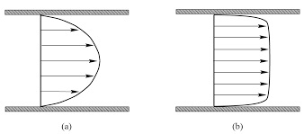
SHEAR STRESS PROFILE:  - Laminar Sub layer region ($τ_{turb}=0$)  - Overlap/ Buffer region  - Outer Turbulent Region ($τ_{vis}=0$) | 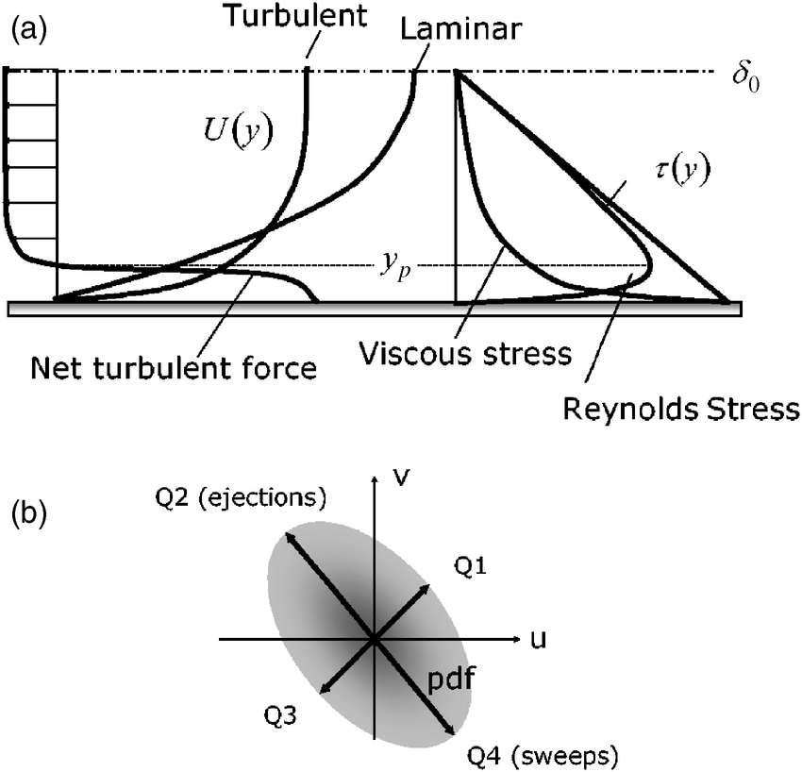
LAMINAR SUB LAYER REGION:
A very thin region adjacent to the wall of a pipe where $τ_{vis}$ heavily dominates over $τ_{turb}$.
- $τ=τ_{vis}$
- The velocity profile in laminar sub layer is almost linear.
- Laminar Sublayer thickness $δ^{'}={A υ}/{V^{*}}, Where A=11.6 \& υ$ is kinematic Viscosity.
- $δ^{'}$ is important to understand the roughness characteristics of a pipe.
ROUGHNESS IN PIPES: Average height of irregularity at the inner wall of a pipe is called roughness in pipe ($ε or K$).
HYDRODYNAMICALLY SMOOTH SURFACE:
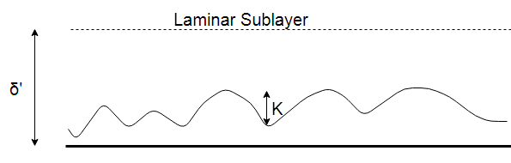 | 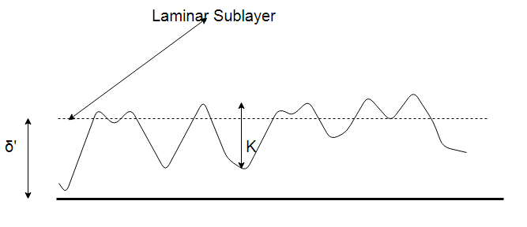
If the value of ‘K’ is smaller or less, then the boundary is known as Hydrodynamic Smooth. And $f=g\left(Re\right)only$.
For Hydrodynamic smooth pipes ($ε/{δ^{'}}≤0.25$),
$$Blasius Eq.: f=\frac{0.316}{{Re}^{0.25}}, Where Re≤{10}^{5}$$ | $$Nikuradses’s Eq.:\frac{1}{\sqrt{f}}=2\log_{10}\left(Re \sqrt{f}\right)-0.8$$
If the value of ‘K’ is large for a boundary then the boundary is called as Hydrodynamic Rough. And $f=g\left(ε\right)only$.
For Hydrodynamic Rough pipes ($ε/{δ^{'}}≥6$), | $$Nikuradses’s Eq.:\frac{1}{\sqrt{f}}=2\log_{10}\left(\frac{R}{ε} \right)+1.74$$ | Where, R is Radius.
For Pipe in Transition ($0.25<ε/{δ^{'}}<6$),$f=g\left(Re,ε\right)$
Hydrodynamic ($ε/{δ^{'}}={εV^{*}}/{11.6 υ}$) means, it depends on surface, dynamic property and fluid property.
Based on only surface roughness we can’t judge about the flow. We need both $ε \& δ^{'}$ both to know about the flow.
VELOCITY FORMULAS:
$$V^{*}=\sqrt{\frac{τ_{0}}{ρ}}=V\sqrt{\frac{f}{8}}⋯(1)$$ | $$\frac{u_{max}-V}{V^{*}}=3.75⋯(2)$$ | $$\frac{u_{max}}{V}=1+1.43\sqrt{f}⋯(3)$$
For Hydrodynamic smooth pipes,
$$\frac{u}{V^{*}}=5.75 \log_{10}\left[\frac{\left(R-r\right)V^{*}}{υ}\right]+5.5⋯(4)$$ | $$\frac{u_{max}}{V^{*}}=5.75 \log_{10}\left[\frac{RV^{*}}{υ}\right]+5.5 \left(From 4\right)⋯(5)$$
$$\frac{V}{V^{*}}=5.75 \log_{10}\left[\frac{RV^{*}}{υ}\right]+1.75 \left(From 2 \& 5\right)⋯(6)$$ | $$\frac{u_{max}-u}{V^{*}}=5.75 \log_{10}\left[\frac{\left(R-r\right)}{R}\right] (From 4 \& 5)⋯(7)$$
For Hydrodynamic Rough pipes,
$$\frac{u}{V^{*}}=5.75 \log_{10}\left[\frac{R-r}{ε}\right]+8.5⋯(8)$$ | $$\frac{u_{max}}{V^{*}}=5.75 \log_{10}\left[\frac{R}{ε}\right]+8.5 \left(From 8\right)⋯\left(9\right)$$
$$\frac{V}{V^{*}}=5.75 \log_{10}\left[\frac{R}{ε}\right]+4.75 \left(From 2 \& 8\right)⋯(10)$$ | $$\frac{u_{max}-u}{V^{*}}=5.75 \log_{10}\left[\frac{R}{R-r}\right] (From 8 \& 9)⋯(11)$$
COMMERCIAL PIPES:
PRACTICAL PROBLEMS
How to measure $ε$ | If $ε$ is known, how to measure $δ^{'}$ because it varies w.r.t.$V \& υ$. So, finding $f$ is difficult.
SOLUTION:
- EQUIVALENT PIPE: Create other pipe with same Property $Q,L,D$ such that head loss remains same. So, From the known pipe surface roughness by comparing we can obtain surface roughness of unknown pipe.
- COLEBROOK-WHITE EQUATION:
$$\frac{1}{\sqrt{f}}=-2\log_{10}\left[\frac{Z}{3.7}+\frac{2.51}{Re\sqrt{f}}\right]$$ | $$f=g\left(Re, \frac{ε}{D}\right),Where \frac{ε}{D}=Z=Relative Roughness$$
- Graphical Representation of Colebrook-White equation is known as Moody’s chart.
- HAALAND’S EQUATION:
$$\frac{1}{\sqrt{f}}=-1.8\log_{10}\left[{\left(\frac{Z}{3.7}\right)}^{1.1}+\frac{6.9}{Re}\right]$$
MOODY’S CHART:
- For turbulent flow through Smooth pipe friction factor continuously decreases with $Re$.
- For turbulent flow through Rough pipe friction factor initially decrease w. r. t. $Re$ but after certain $Re$ it remains contestant. And the critical value of $Re$ is not fixed. It decreases w. r. t. $ε/D$.
- For same $Re$ as $ε/D$ increases $f$ increases.
- For laminar flow through Rough/ Smooth pipe friction factor continually decreases w. r. t. $Re$.
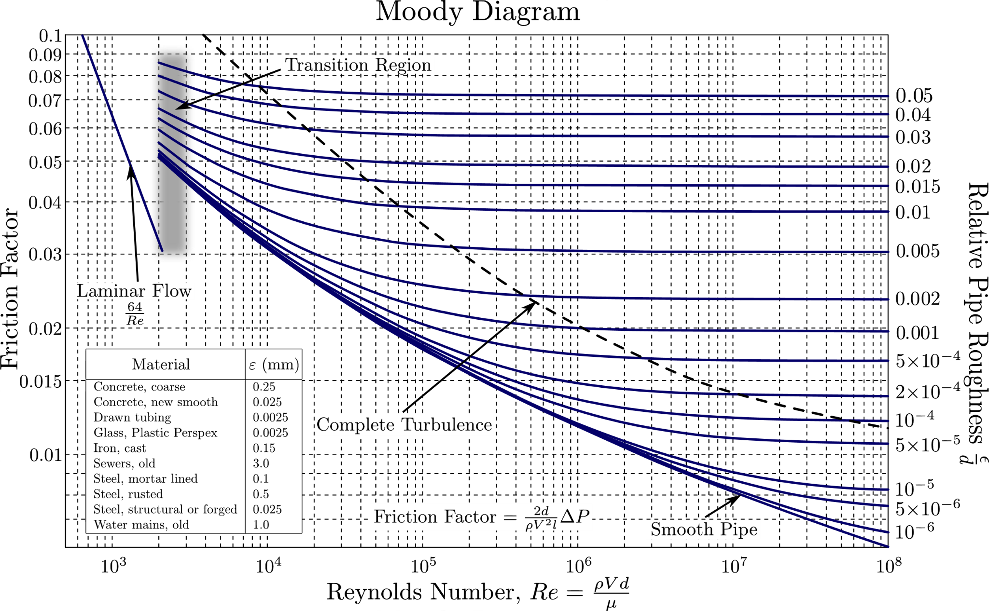
AGEING OF PIPES:
- Surface roughness increases linearly w. r. t. time.  $$ε_{t}=ε+αt, Where α=Rate of increase in roughness$$  $α$ is material property and Depends surroundings.  - $ε↑ ⇒f↑ ⇒Q↓$  $$fQ^{2}∝h⇒For constant head loss,\frac{df}{f}=-2\frac{dQ}{q}⇒\left(\begin{aligned}Rate of↑ \\ in "f"\end{aligned}\right)=2\left(\begin{aligned}Rate of↓ \\ in "Q"\end{aligned}\right)$$ | 